
Actions
City of Charlottesville
Board of Architectural Review
Regular Meeting
May 16, 2023, 5:30 p.m.
Hybrid Meeting (In-person at CitySpace and virtual via Zoom)

Pre-Meeting Discussion

Regular Meeting

A. Matters from the public not on the agenda [or on the Consent Agenda] (please limit to 3 minutes per speaker)

B. Consent Agenda (Note: Any consent agenda item may be pulled and moved to the regular agenda if a BAR member wishes to discuss it, or if any member of the public is present to comment on it. Pulled applications will be discussed at the beginning of the meeting.)

- Meeting minutes: March 21, 2023

2. Certificate of Appropriateness Application
BAR # 23-05-03
485 14th Street NW, TMP 090034000
Rugby Road-University Circle-Venable ADC District
Owner: Hoo House, LLC
Applicant: Greg Winkler, Kurt Wassenaar
Project: Rear addition

Motion to approve Consent Agenda by Mr. Schwarz. Second by Mr. Bailey. Vote 7-0, motion passed unanimously with the following conditions:

Approval: Having considered the standards set forth within the City Code, including the ADC District Design Guidelines, I move to find that the proposed rear addition (Phase 3) at 485 14th Street, NW, satisfies the BAR’s criteria and is compatible with this property and other properties in this ADC District, and that the BAR approves the application as submitted, with the following conditions:
- There will be a concrete foundation.*
- There will be a fiber cement soffit and a standard aluminum gutter.*
- There will be a tall frieze board above the window heads.*
- No additional lighting is indicated; however, all exterior lighting will have lamping that is dimmable, have a CCT that does not exceed 3000 K, and will have a CRI not less than 80, preferably not less than 90.
- The trim color should match Phase 2.
- New mechanical units and meter/utility boxes will be located at/near the rear (west) and/or side (south) elevations of the Phase 3 addition.
- Railings at the rear (west) elevation: Wood or metal, painted. Design should be simple and traditional--square pickets centered on top and bottom rails, which can be square material or have traditional profiles. An alternate such as a cable railing can be considered. Railings with vinyl or PTP material and/or with pickets applied to the sides of the top and bottom rails are not permitted. (See images below.) The BAR allows for staff review of the railing design, provided they consult with the BAR chairs.
[* Match or similar to Phase 2.]

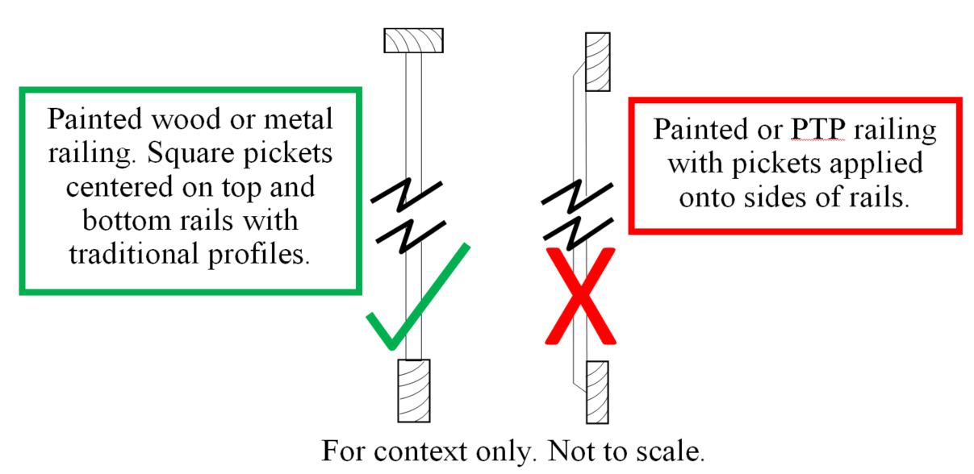

C. Deferred Items
No items

D. New Items
3. Certificate of Appropriateness Application
BAR # 23-05-01
180 Rugby Road, TMP 090152000
The Corner ADC District
Owner: Wooglin Company
Applicant: Ian Brown / UVREF
Project: Landscaping

Motion by Mr. Schwarz to accept applicant’s request for a deferral. Second by Mr. Zehmer. Motion passed, 7-0. BAR requested applicant submit sample of the turf grass and information regarding its installation and maintenance, spec sheets for the pathway lighting, and measured drawings for the proposed brick piers, with a recommendation that the widths not exceed 18” and that, as important design elements on the site, the piers complement, but not mimic, the architecture of the house.

4. Certificate of Appropriateness Application
BAR # 23-05-02
410 2nd Street NE, TMP 330078000
North Downtown ADC District
Owner: Sherry Kraft
Applicant: Annie Mathot
Project: Rear alterations

Motion to approve CoA by Mr. Bailey. Second by Mr. Schwarz. Motion passed, 7-0.
Approval: Having considered the standards set forth within the City Code, the ADC District Design Guidelines, I move to find that the proposed rear alterations at 410 2nd Street NE satisfy the BAR’s criteria and are compatible with this property and other properties in this ADC District, and that the BAR approves the application as submitted with the following conditions: with a condition that new exterior lighting be reviewed and approved by staff. [Specifically, confirm the lamping will be dimmable, have a Color Temperature (CCT) not exceeding 3,000K, and a Color Rendering Index (CRI) not exceeding 80, preferably not exceeding 90.]

E. Other Business
5. Preliminary discussion
704 Park Street, TMP 520061000
North Downtown ADC District
Owner: Lauren Kenney
Applicant: Leigh Boyes
Project: Replace windows, paint brick
No action taken.

6. Preliminary discussion
DT Mall
- Coca-Cola sign
- Historic building recognition
No action taken.

7. Staff questions/discussion
    - DT Mall NRHP update
    - Zoning re-write questions
    - Café space shades

F. Adjourn

